**Real Time Project 1 :-** ✔ Practical 27 :CI / CD Pipeline of Java Spring boot application via- - GitHub + Jenkins CI + Jenkins file + Docker build and Deploy to Dev Remote Machine

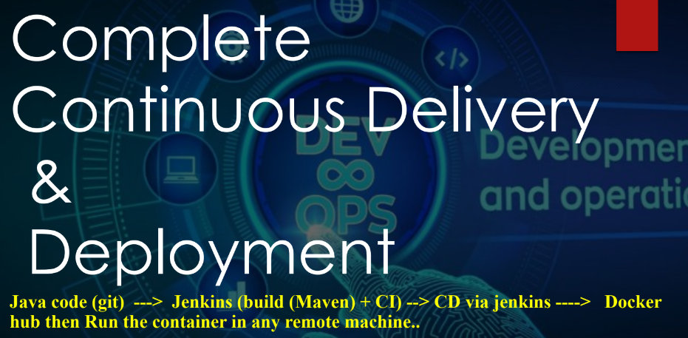

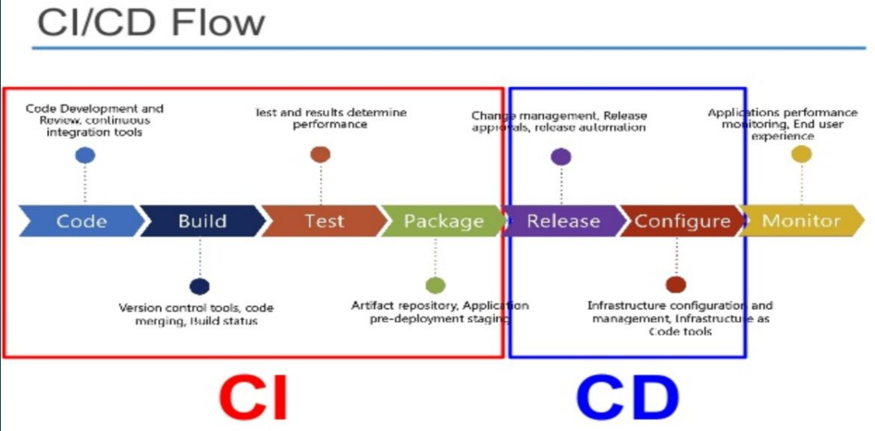

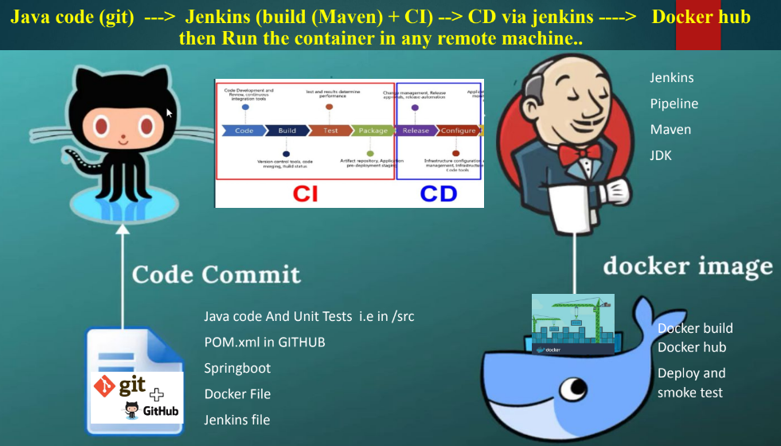

GCP console🡪VM instance🡪create instance

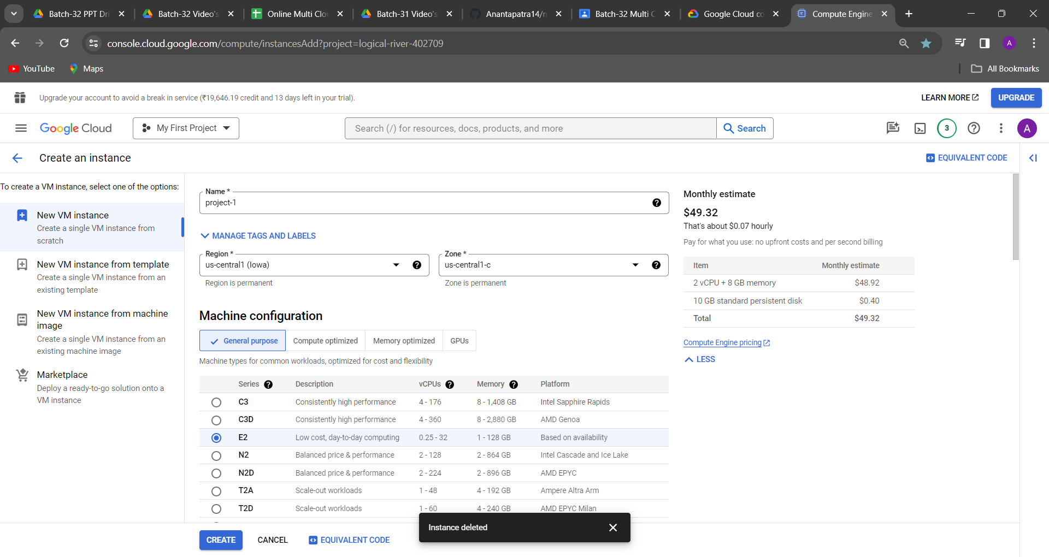

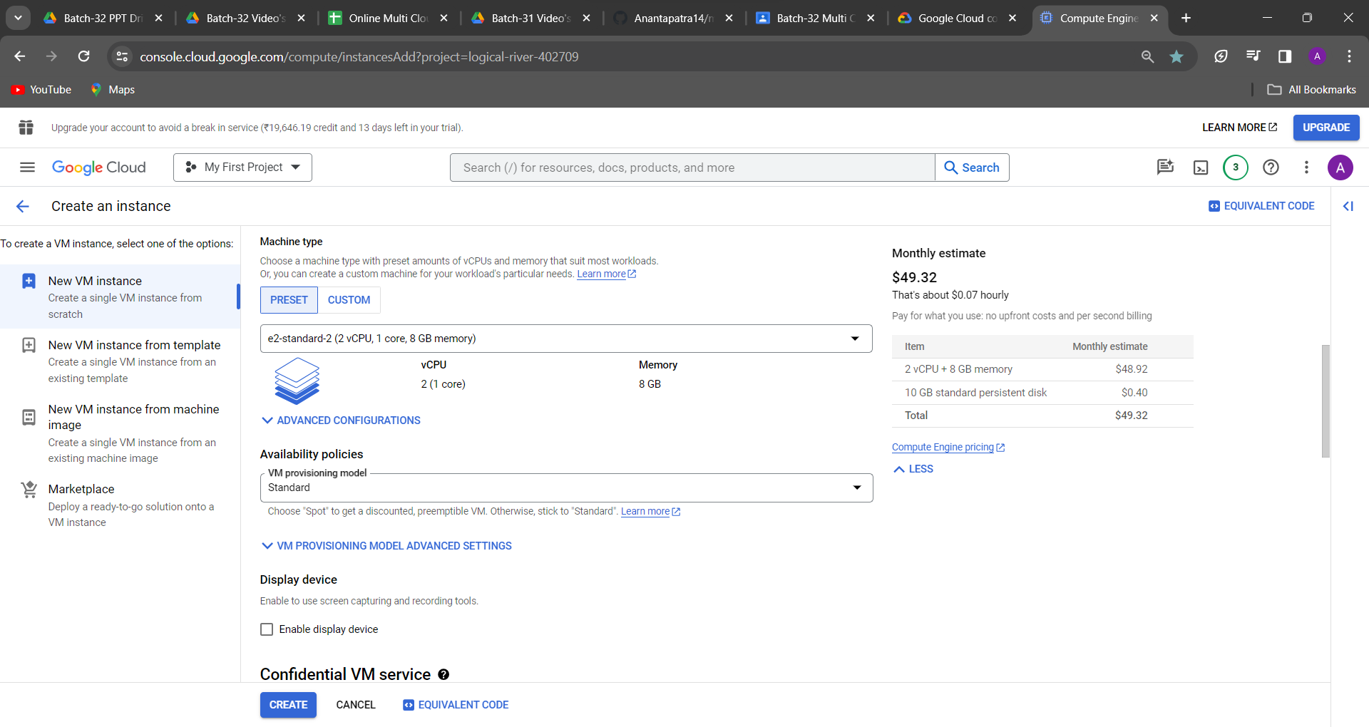

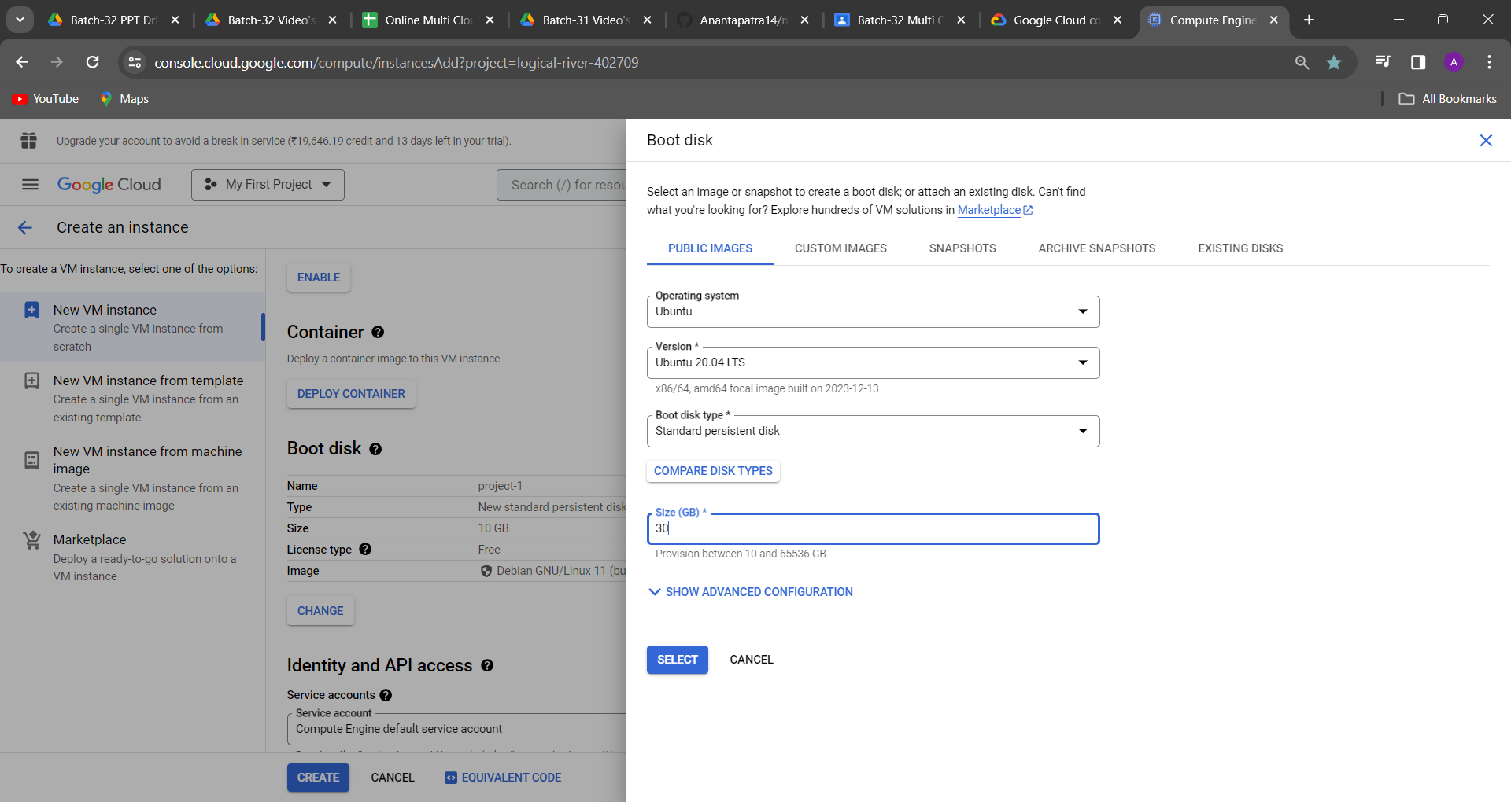

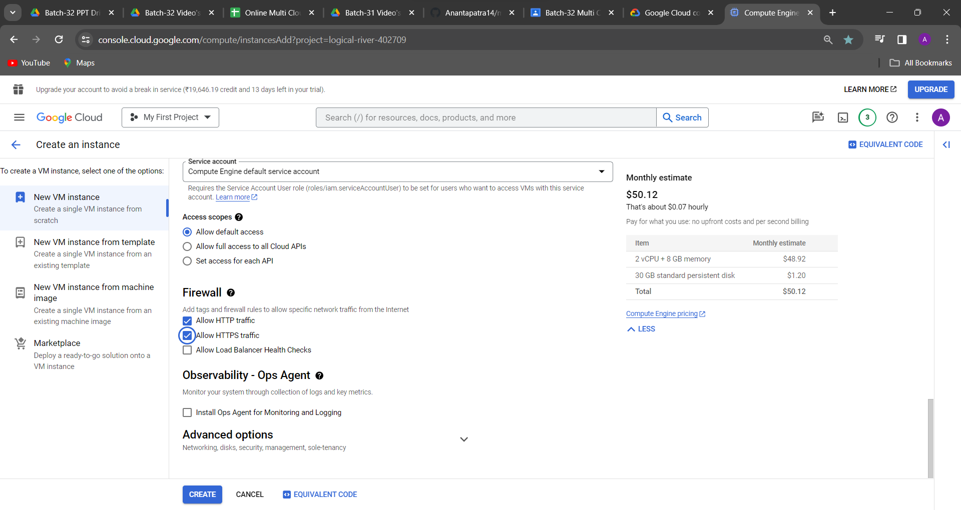

Click on create then machine will ready

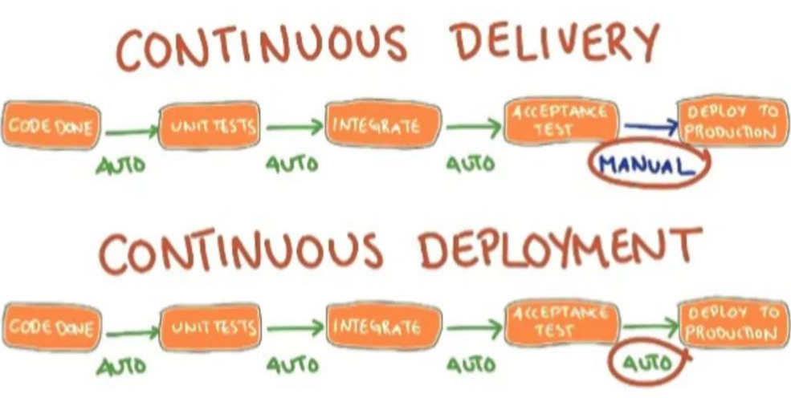

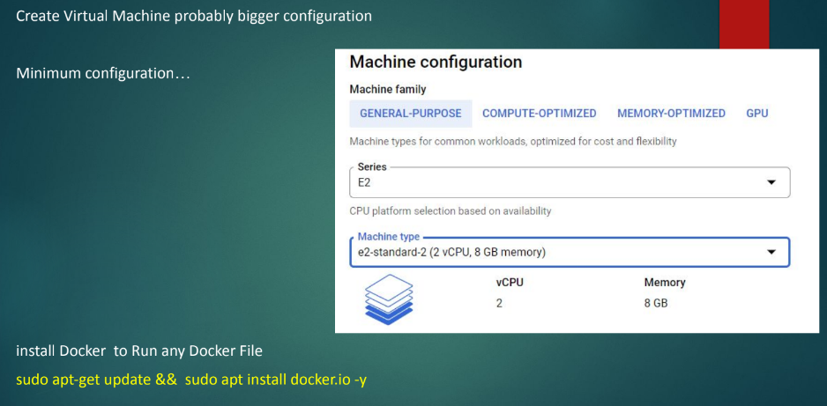

Then project-1 connect with SSH

Running this command: “sudo apt-get update && sudo apt install docker.io -y”

i.e two things will happen that is package update and docker will be installed in this mahine

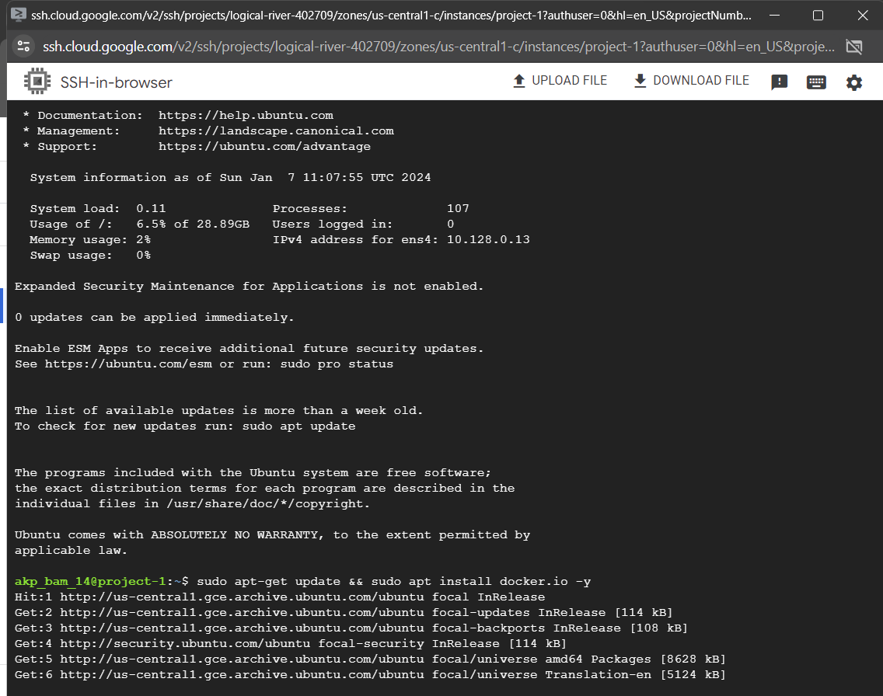

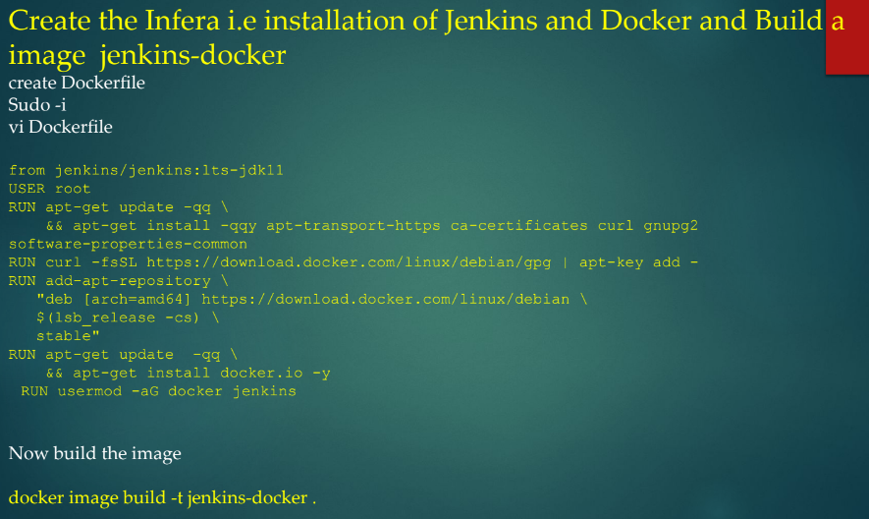

sudo -i

vi Dockerfile

then paste this code :

from jenkins/jenkins:lts-jdk11

USER root

RUN apt-get update -qq \

&& apt-get install -qqy apt-transport-https ca-certificates curl gnupg2 software-properties-common

RUN curl -fsSL https://download.docker.com/linux/debian/gpg | apt-key add -

RUN add-apt-repository \

"deb [arch=amd64] https://download.docker.com/linux/debian \

$(lsb_release -cs) \

stable"

RUN apt-get update -qq \

&& apt-get install docker.io -y

RUN usermod -aG docker jenkins

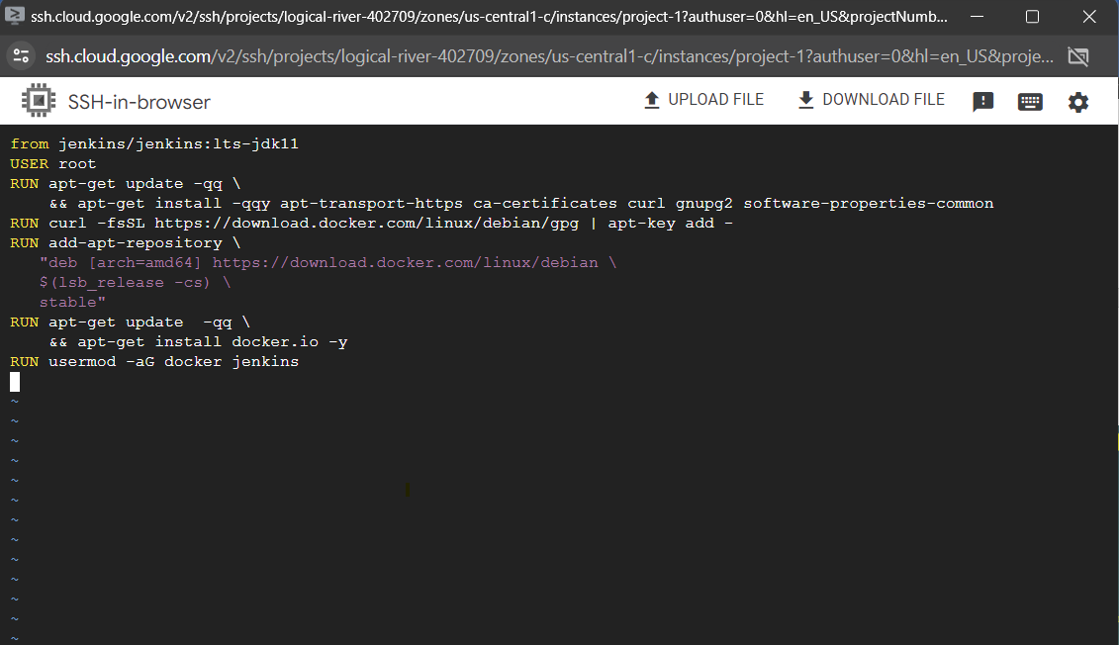

:wq

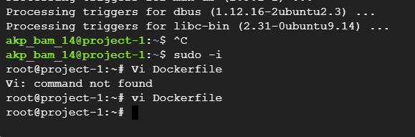

docker images

docker image build -t jenkins-docker .

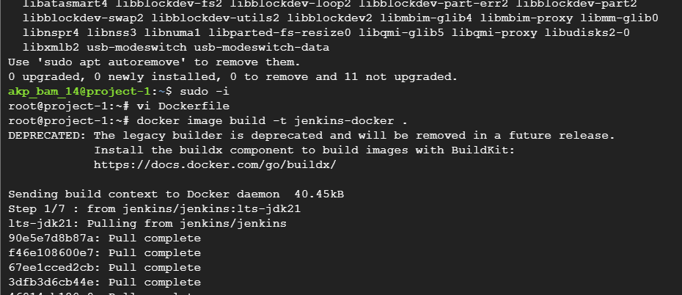

Output is showing

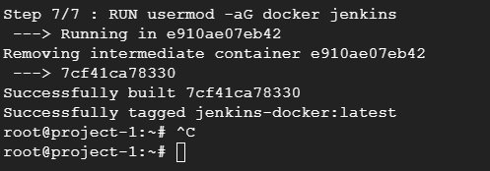

docker images

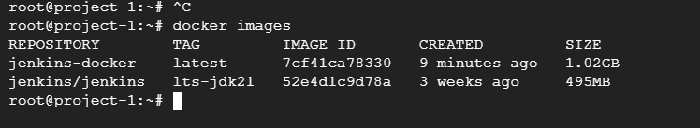

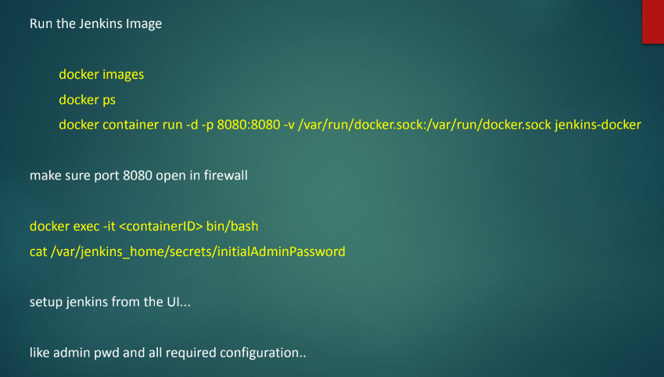

docker ps

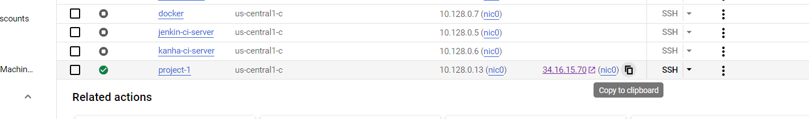

Before that go to this external ip browse it 34.16.15.70:8080, 34.134.98.28:8080

Check it nothing is running

docker container run -d -p 8080:8080 -v /var/run/docker.sock:/var/run/docker.sock jenkins-docker

docker ps

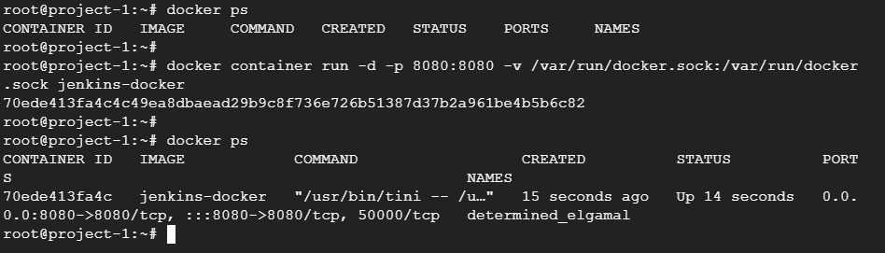

Now one container has been created

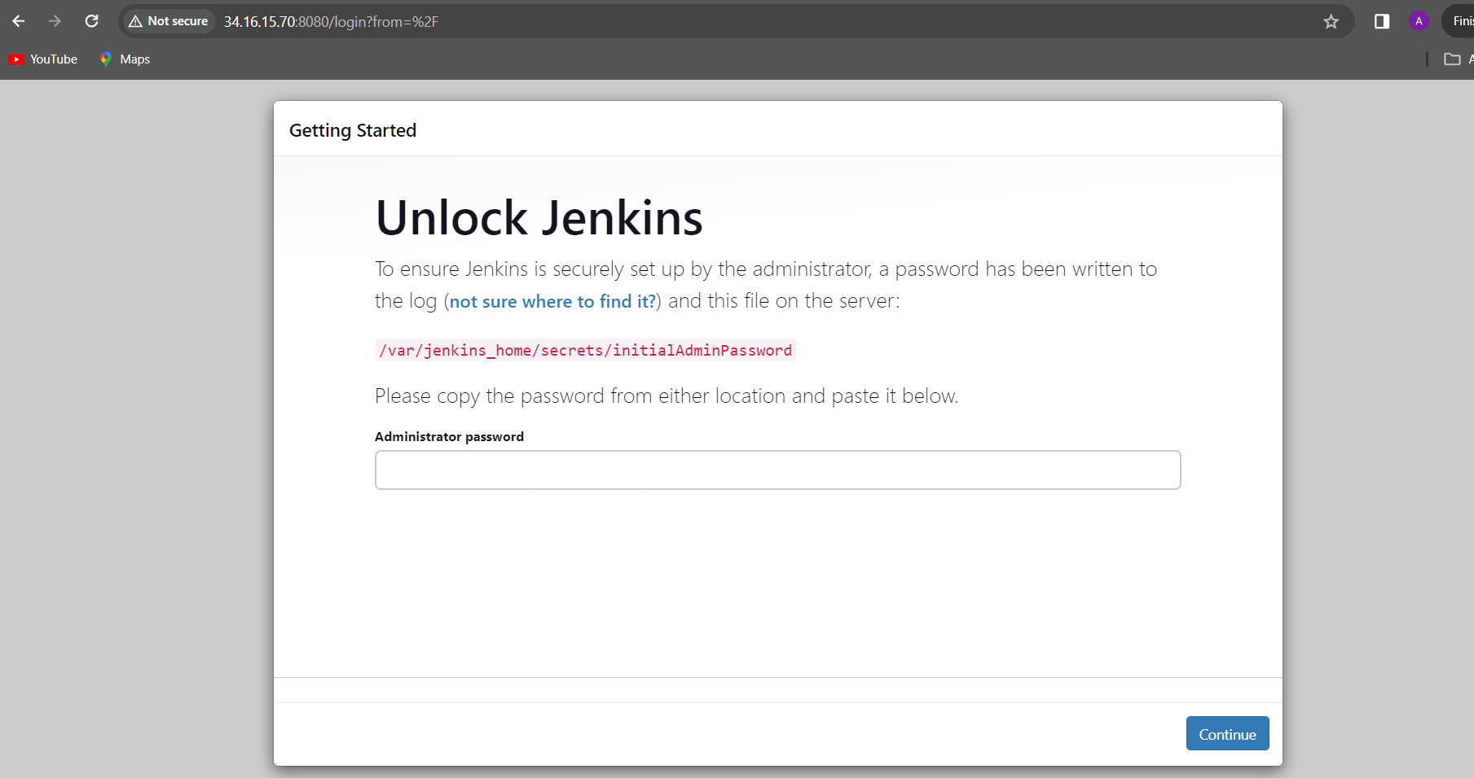

How to get password🡪 you have go to inside the container

docker exec -it 70ede413fa4c bin/bash

cat /var/jenkins_home/secrets/initialAdminPassword

passward: 38dcb6e16b06445e9578c6c71f6ab2a6

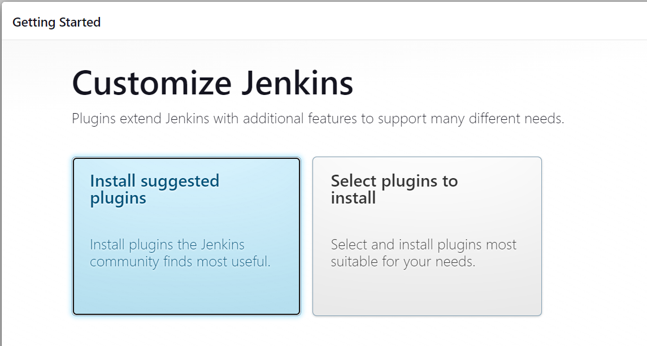

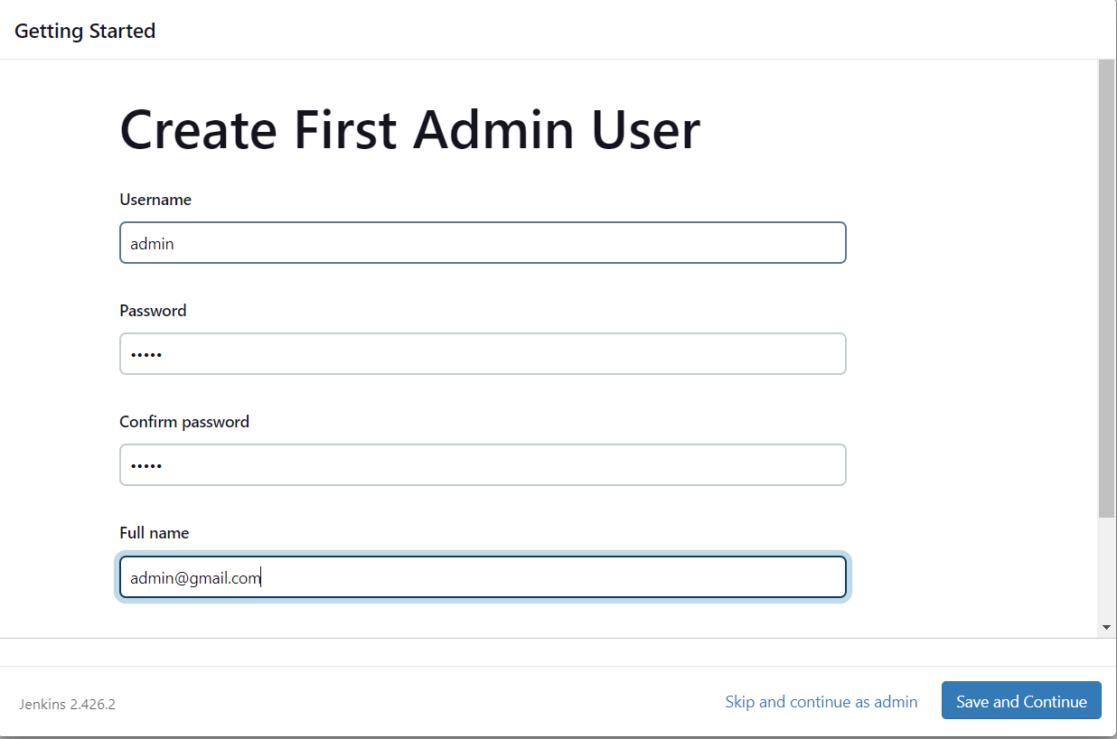

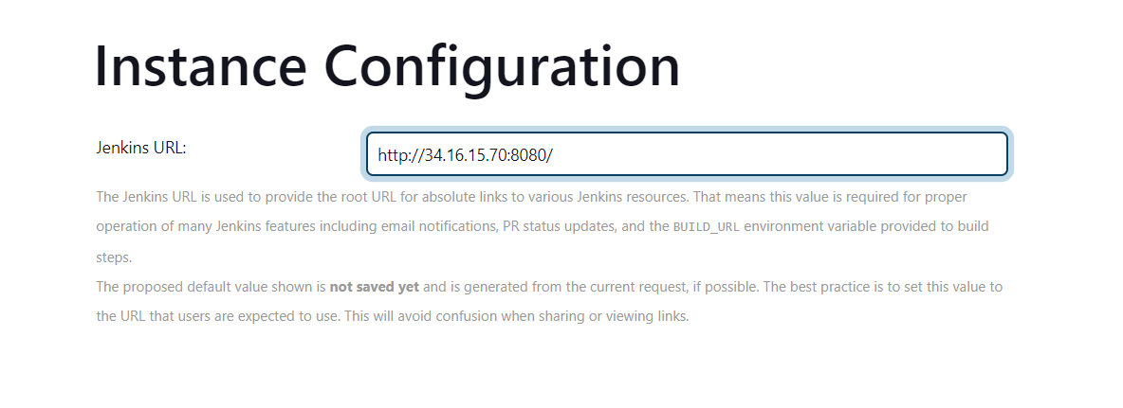

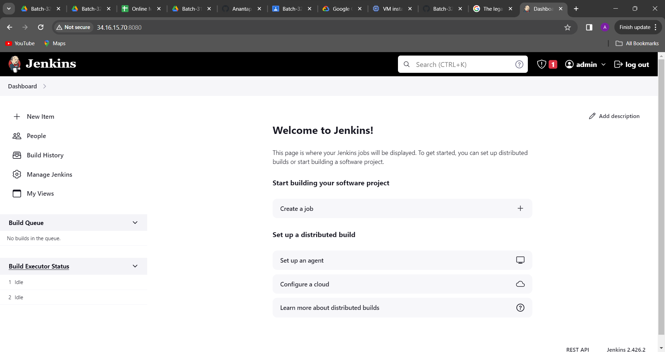

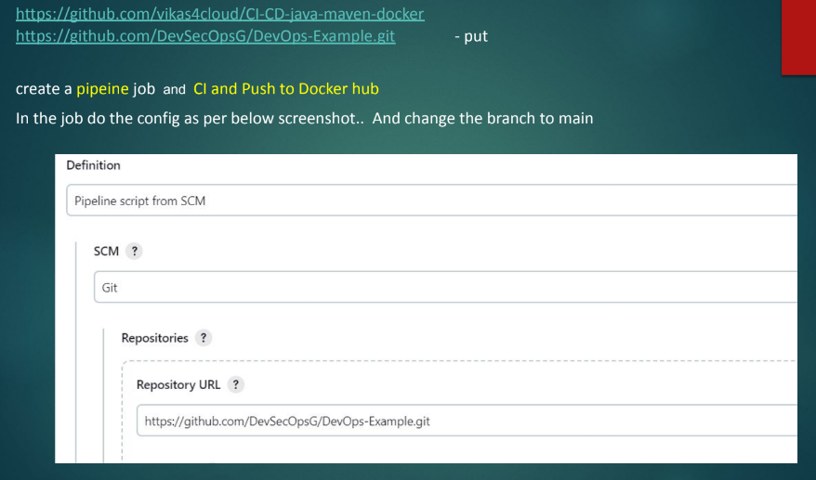

Now I have to create a pipeline jobs

In jenkin🡪 New item🡪name type 🡪 Pipeline🡪ok

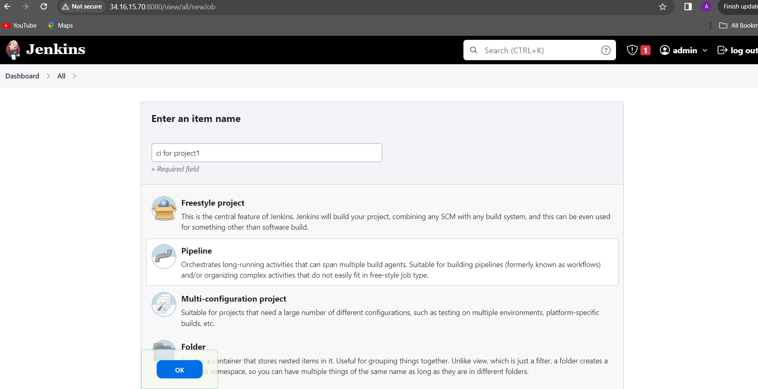

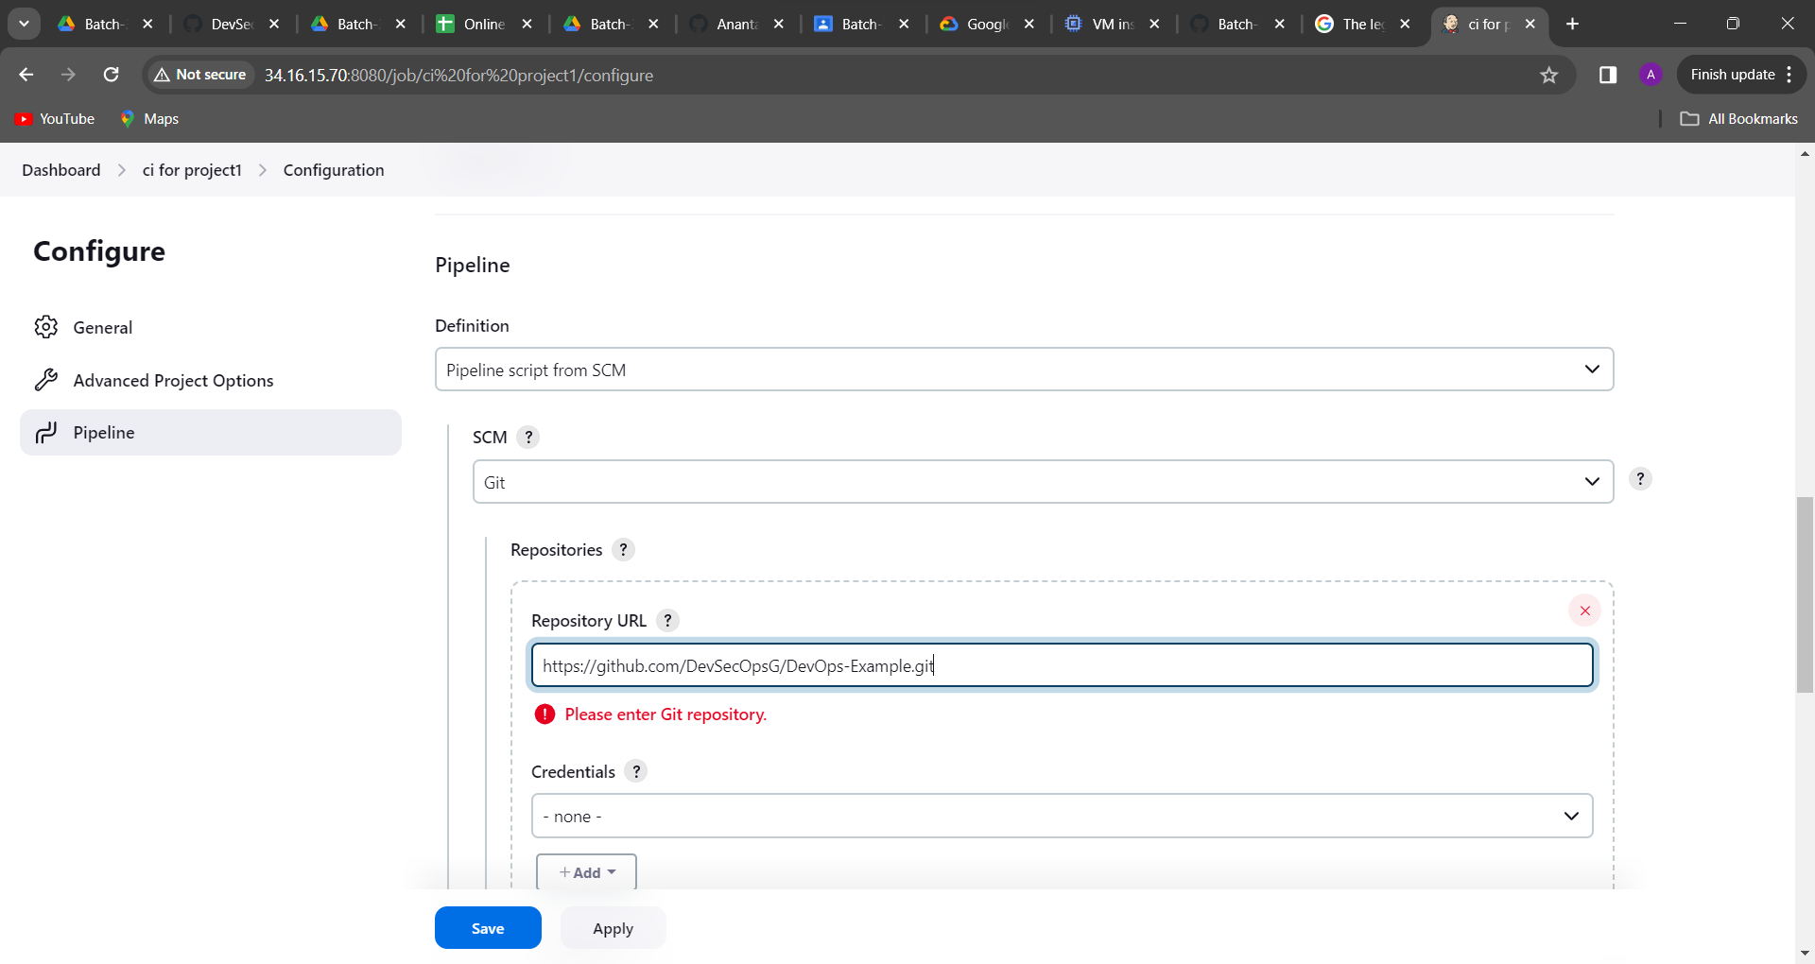

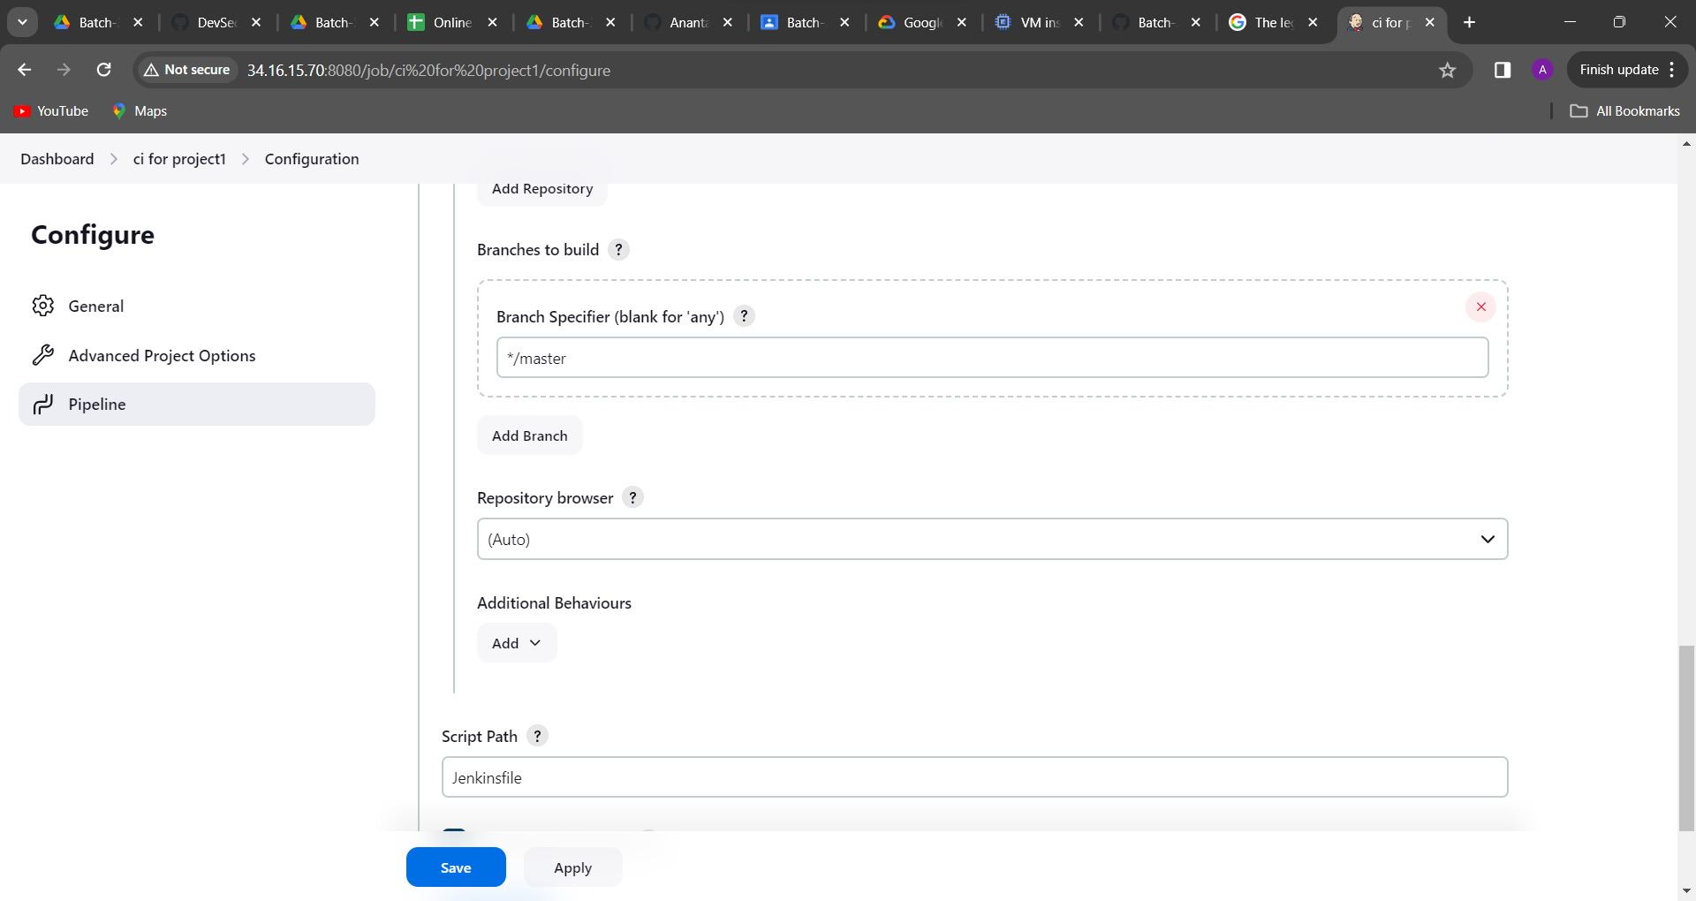

Then click on save and Build Now

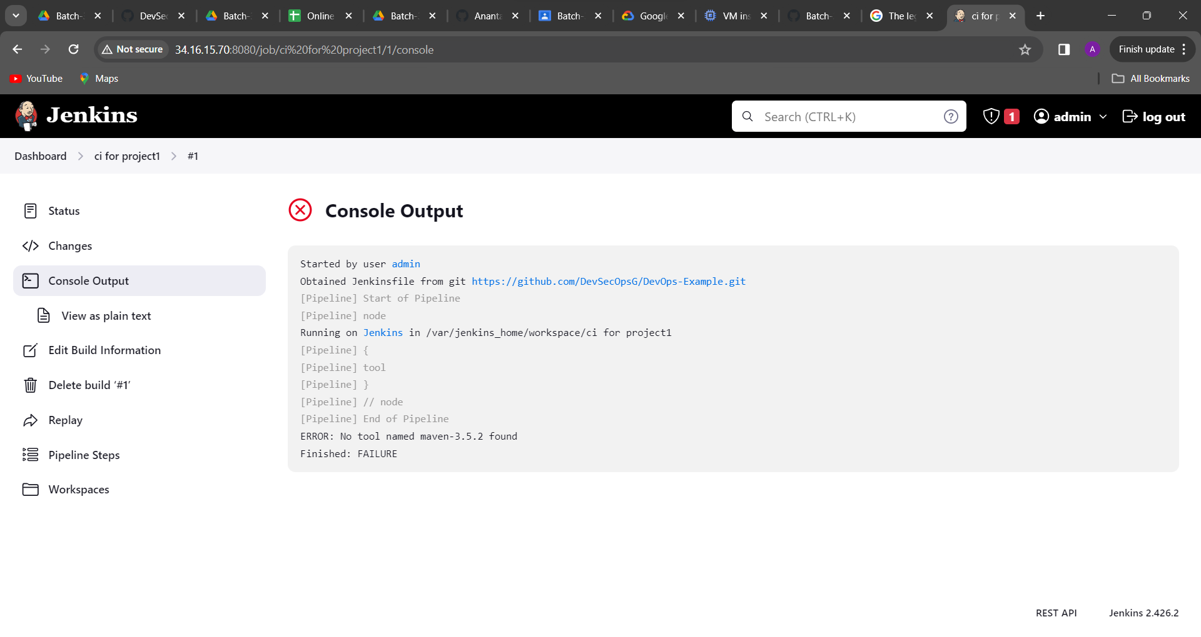

Failed due to maven is not there

Go to manage jenkin🡪Tools🡪Maven installation type maven and vesion🡪 save

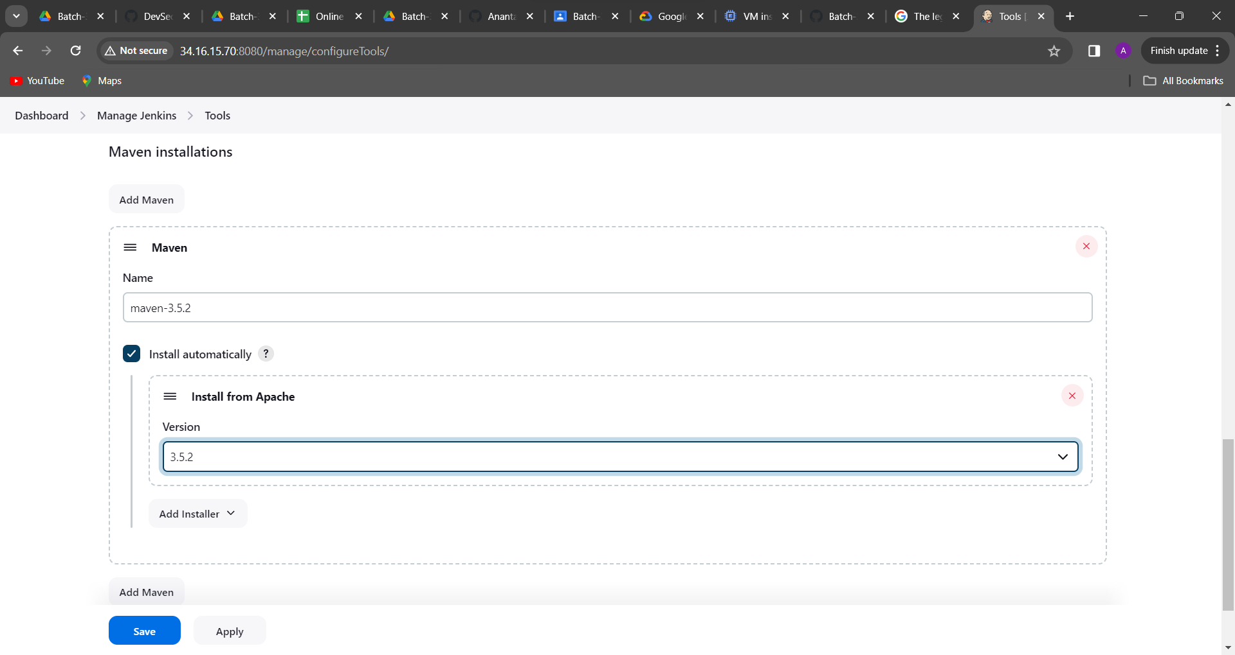

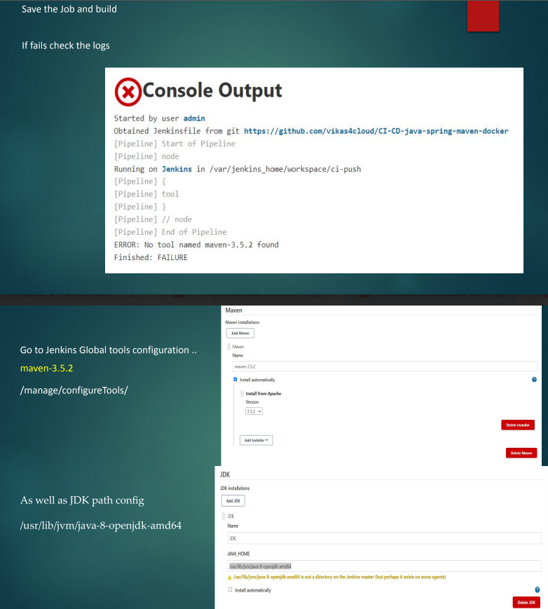

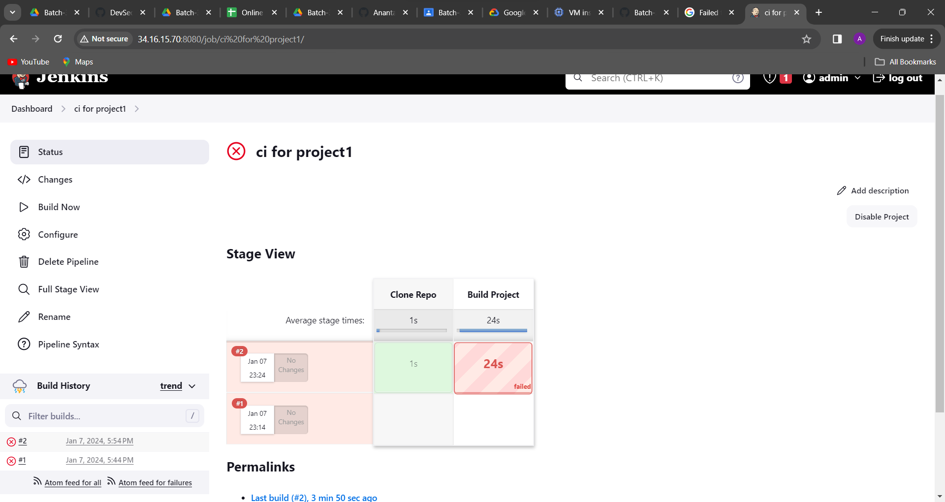

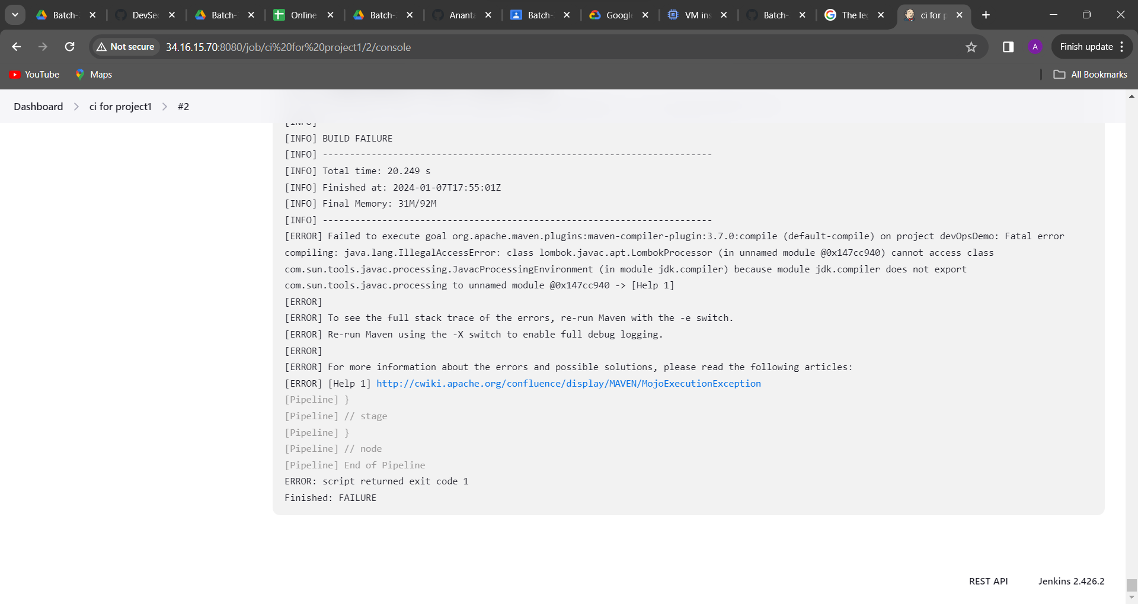again failed but maven dependency have all downloaded

Docker plugin is not there I have to add that

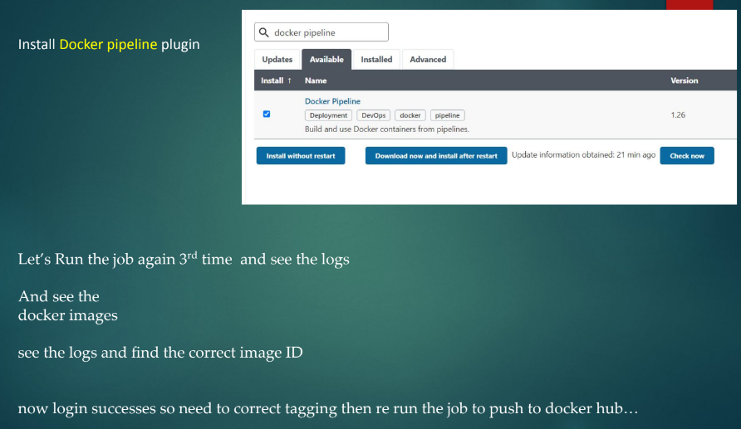

Go to manage jenkin🡪

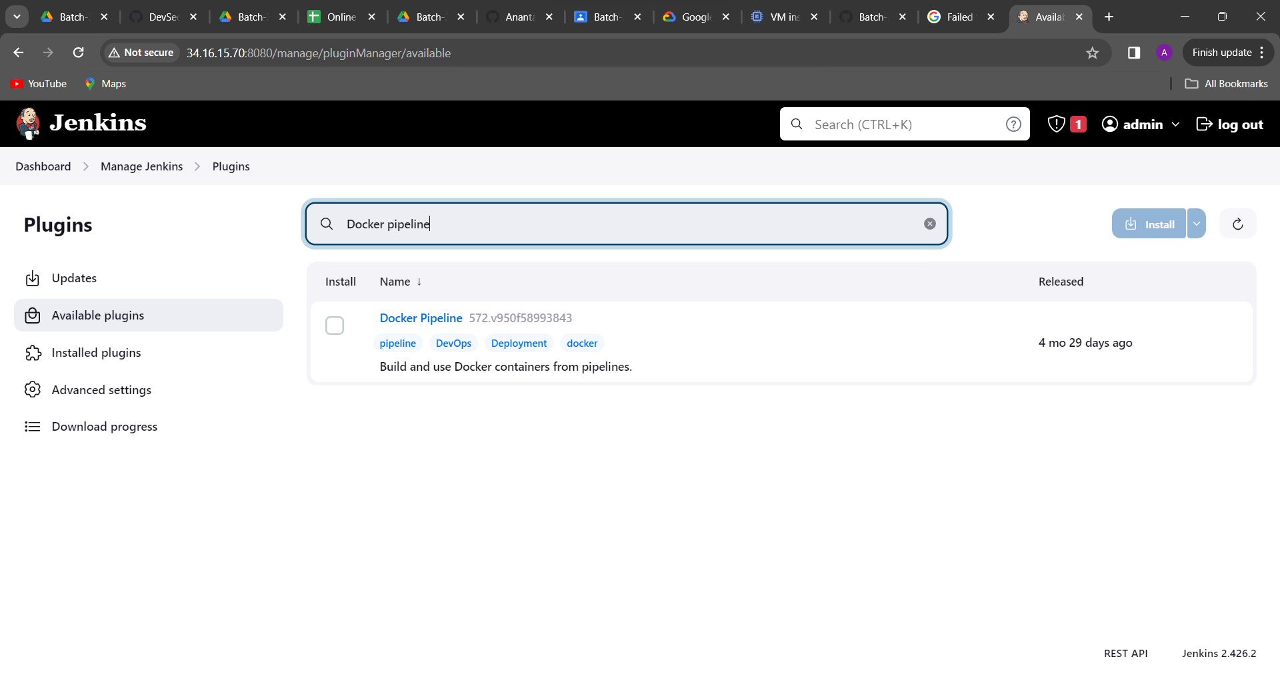

Click on install

Then in scroll down click on Restart Jenkins

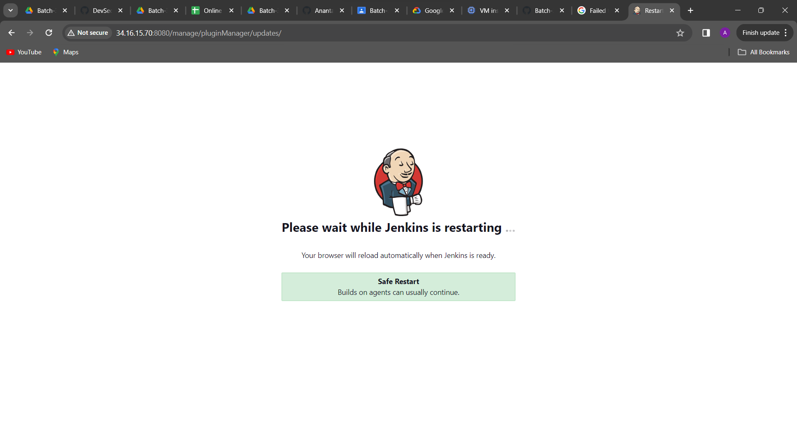

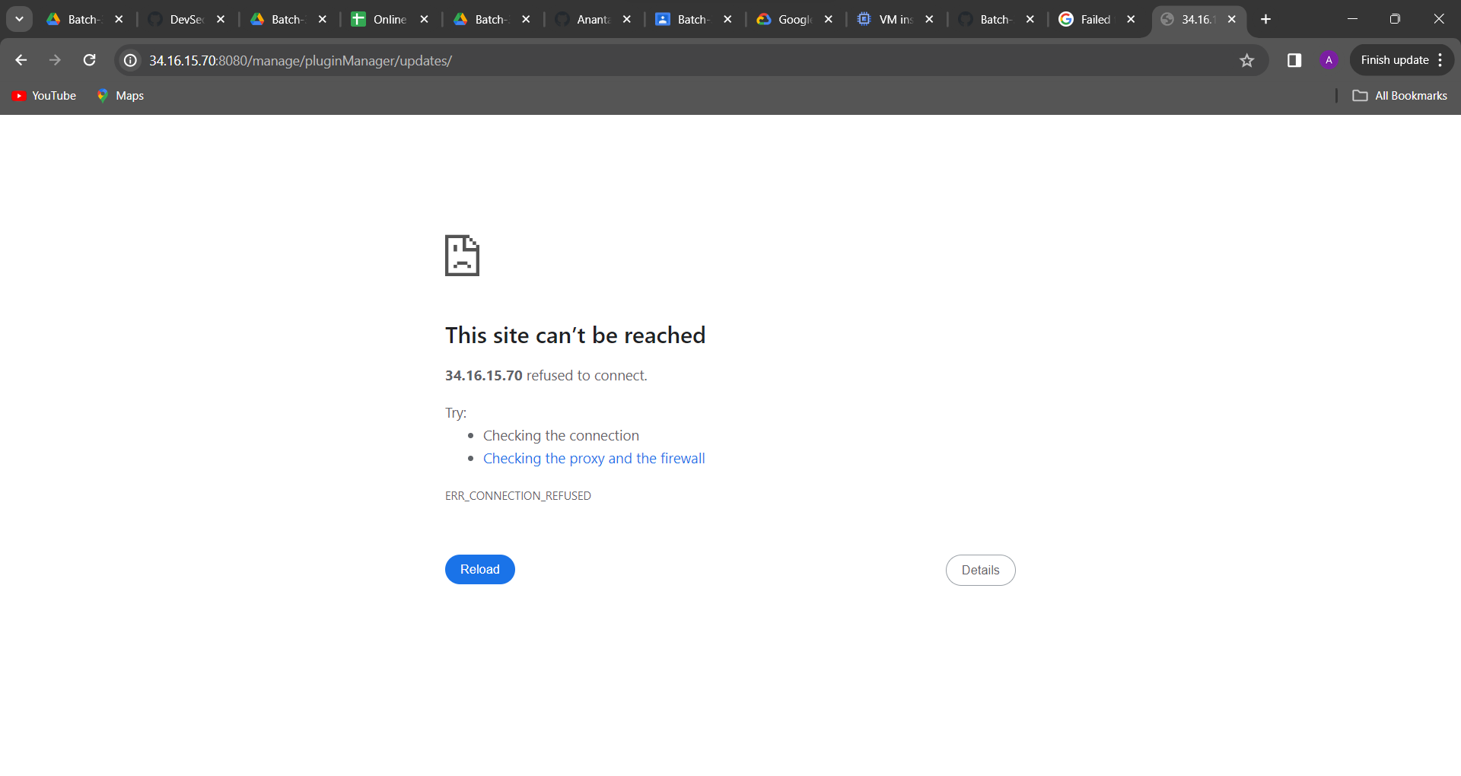

Now docker container not running It came troubleshoot how to fix

Command line:

docker ps

docker ps -a

docker start 70ede413fa4c

docker ps

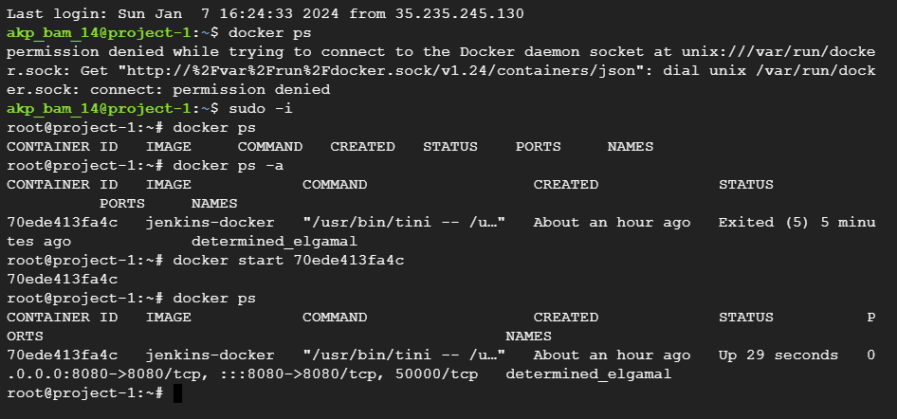

Then again browse it check it

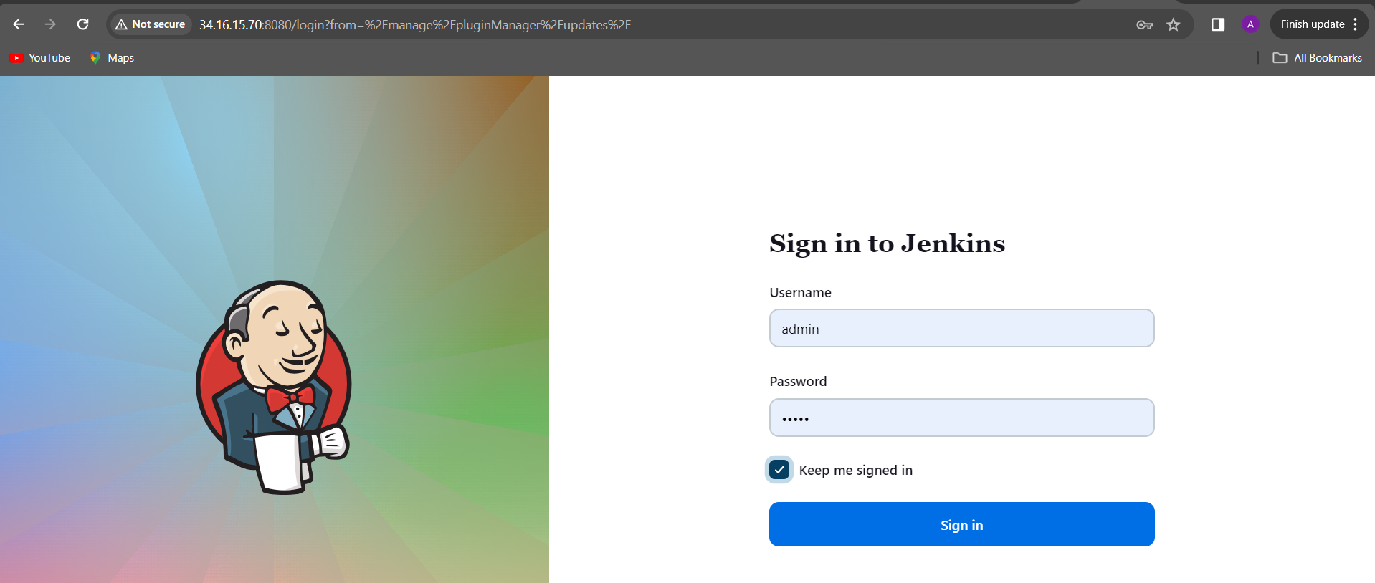

Then again build now it

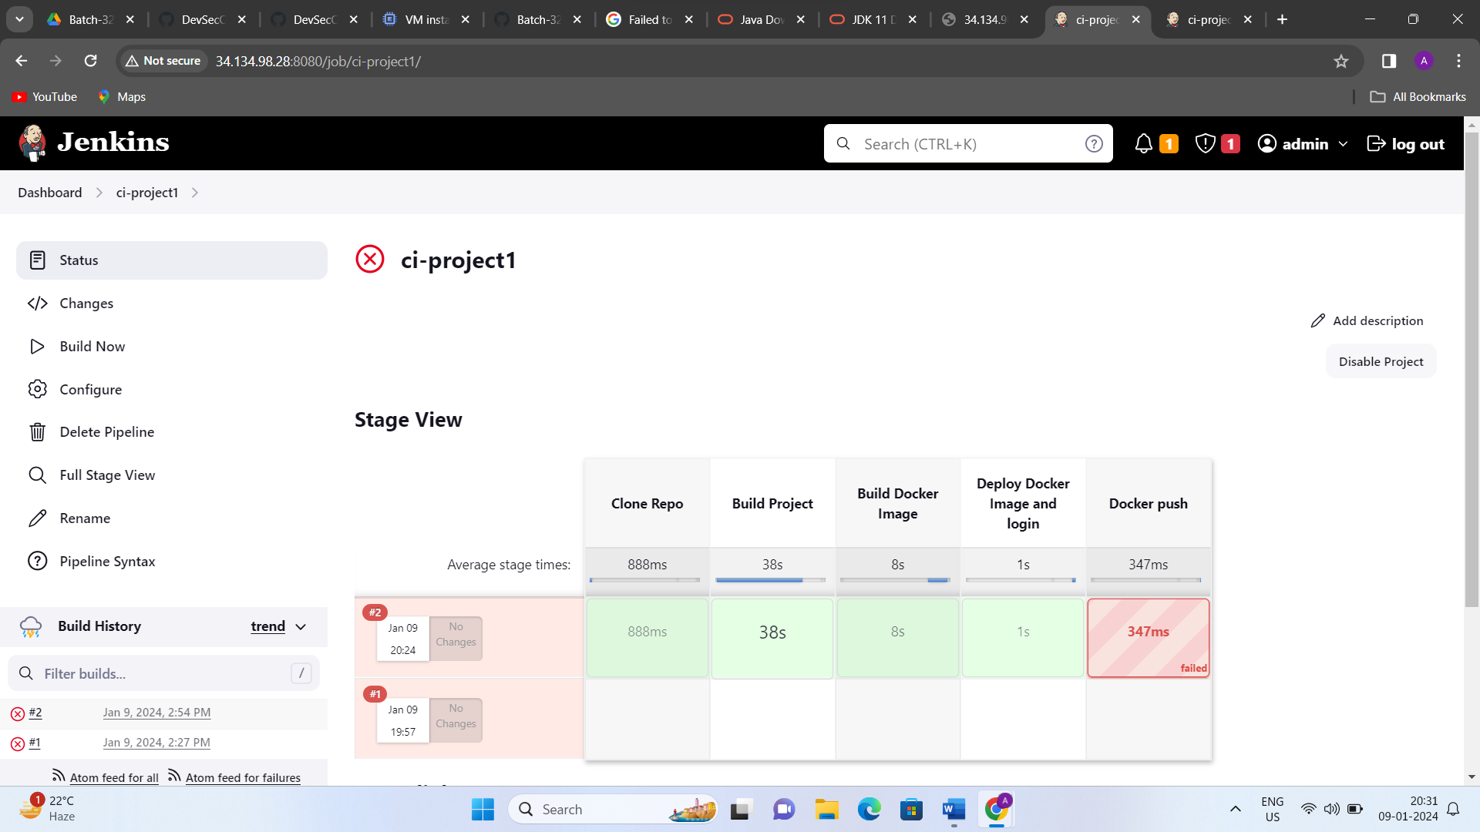

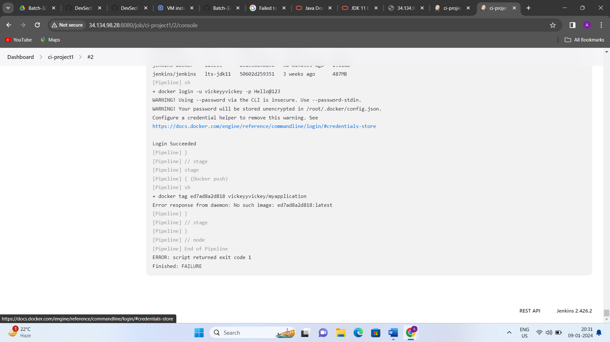

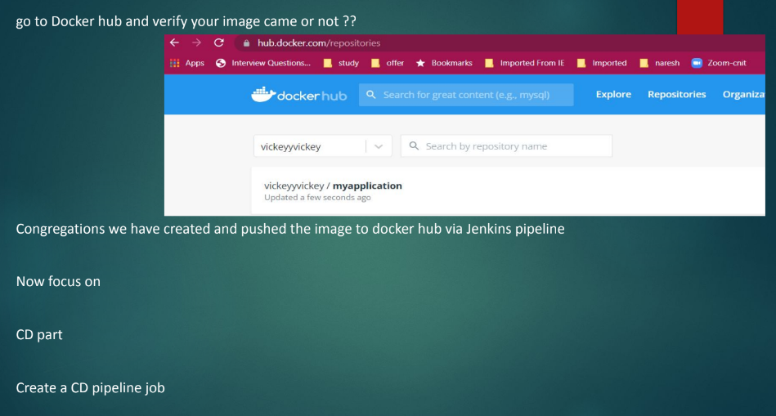

Then you must change your docker hub user name put in git repo in jenkisfile

7f7ec0e6e811

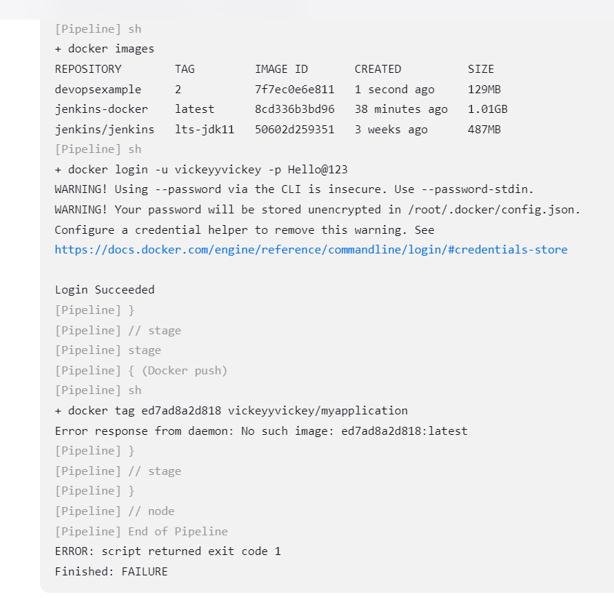

Copy this image id number and paste in git

Then pull request in to your git repo then you can editable and commitchanges.

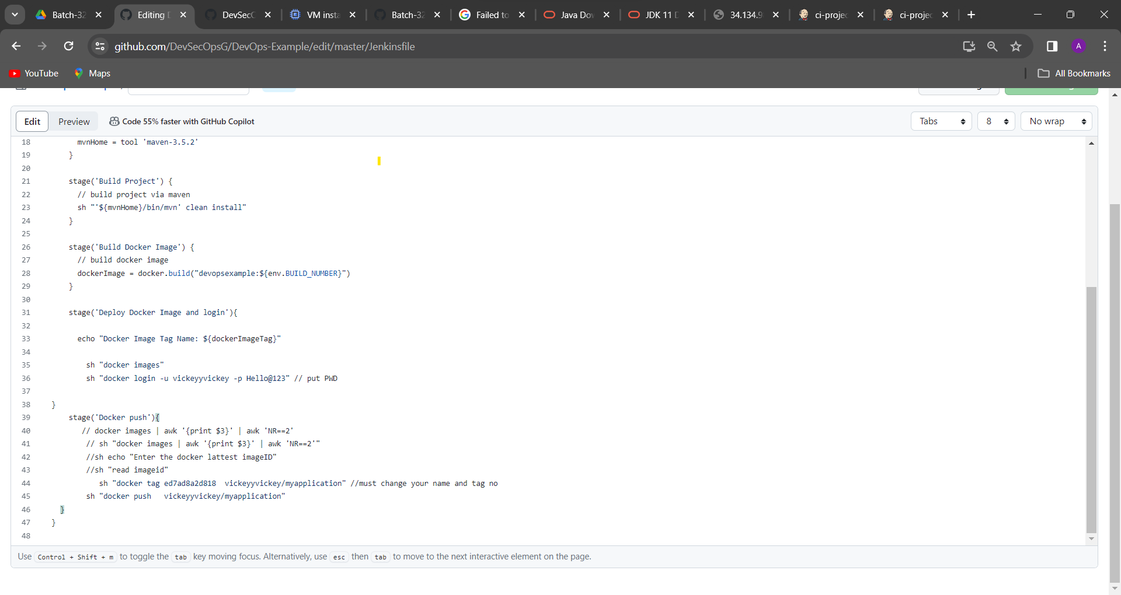

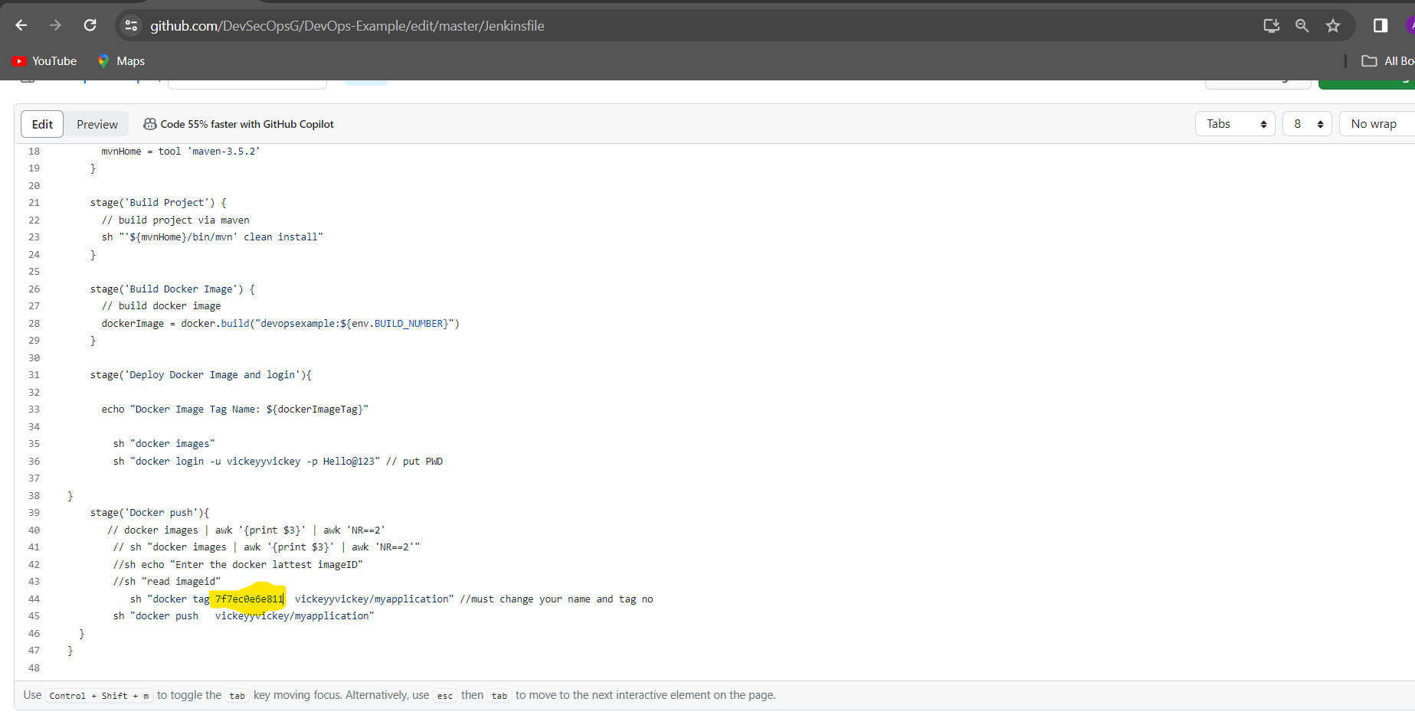

Then click on commit changes

